**PYTHON:**

**Data Types:**

Int, float, string, boolean

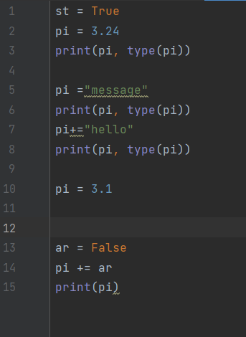

**Output:**

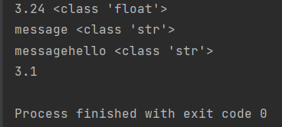

**Logical Operators:**

And, or and not

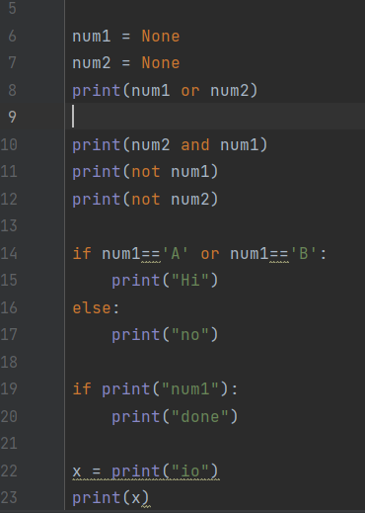

**Output:**

